**CENTURION UNIVERSITY OF TECHNOLOGY AND MANAGEMENTS**



**Assignment 2**

Course Title: System Integration with Dymola

Course Code: CUTM1022 (0-0-2)

**Submitted to:**

***Dr. Sudhansu Kumar Samal***

*Faculty of*

*School of Engineering & Technology, Bhubaneswar*

**Submitted by:**

Name: Kiran Kumar Malik

Registration no: 200301120128

Branch: B-Tech in Computer Science and Engineering’s

Semester: 4th Sem

Section: C

**Experiment No.: 2**

To measure the current in rampVoltage.

**Requirements:**

OpenModelica software

**Procedure:**

Step 1: Open Openmodelica connection editor

Step 2: Click on New Modelica class, give a new Modelica class name, then click on ok

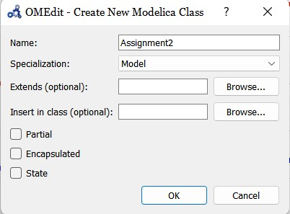

Step 3: Then this type of page will appear

Step 4: Go to Modelica packages, then go to electrical, then analog, then basic, then drag resistor and ground to the modeling field , then choose the constant voltage from source packages.

 I connected the connection between the positive terminal of resistor and rampVoltage, then connected the connection between negative terminal of rampVoltage to the ground. Finnaly connected the connection between negative terminal of the resistor to the ground.

Add some information of the modeling

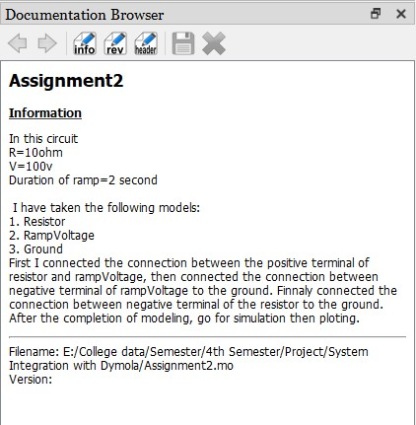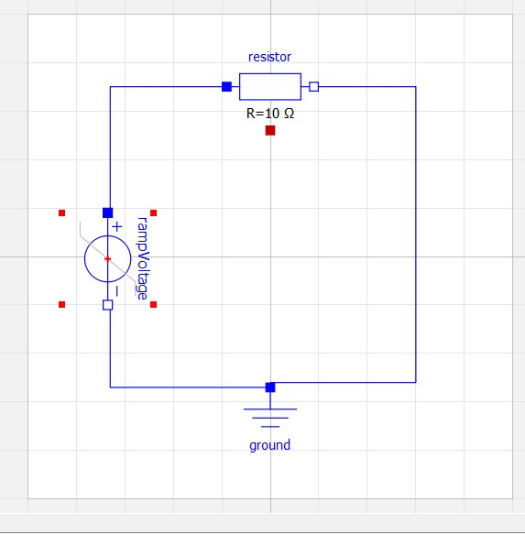

Step 5: After the completion of modeling then save the Modelica file into your pc as .mo extensions, after that go for simulation, when clicking on simulation then compilation occurs, graphical language changes into modelica language.

model Assignment2

Modelica.Electrical.Analog.Basic.Resistor resistor(R = 10) annotation(

Placement(visible = true, transformation(origin = {-1.55431e-15, 70}, extent = {{-18, -18}, {18, 18}}, rotation = 0)));

Modelica.Electrical.Analog.Basic.Ground ground annotation(

Placement(visible = true, transformation(origin = {0, -72}, extent = {{-18, -18}, {18, 18}}, rotation = 0)));

Modelica.Electrical.Analog.Sources.RampVoltage rampVoltage(V = 100, duration = 2) annotation(

Placement(visible = true, transformation(origin = {-67, -1}, extent = {{-19, -19}, {19, 19}}, rotation = -90)));

equation

connect(rampVoltage.p, resistor.p) annotation(

Line(points = {{-66, 18}, {-66, 70}, {-18, 70}}, color = {0, 0, 255}));

connect(rampVoltage.n, ground.p) annotation(

Line(points = {{-66, -20}, {-66, -54}, {0, -54}}, color = {0, 0, 255}));

connect(resistor.n, ground.p) annotation(

Line(points = {{18, 70}, {60, 70}, {60, -52}, {0, -52}, {0, -54}}, color = {0, 0, 255}));

annotation(

uses(Modelica(version = "4.0.0")),

Documentation(info = "<html><head></head><body>In this circuit<div>R=10ohm</div><div>V=100v</div><div>Duration of ramp=2 second<br><div><br></div><div>&nbsp;I have taken the following models:<div>1. Resistor</div><div>2. RampVoltage</div><div>3. Ground</div><div>First I connected the connection between the positive terminal of resistor and rampVoltage, then connected the connection between negative terminal of rampVoltage to the ground. Finnaly connected the connection between negative terminal of the resistor to the ground. After the completion of modeling, go for simulation then ploting.</div></div></div></body></html>"),

Diagram);

end Assignment2;

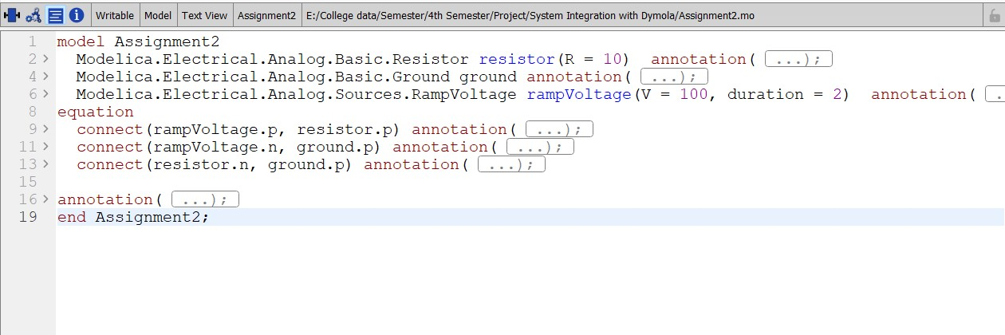

Step 6:after the compilation it will show you a plotting area where you have to plot, as per your given data you have to simulate.

